# Production Programming

## PC-based Programming

There are two ways in which the module can be programmed using the PC:

1. UART-based programming
2. SWD-based programming

### UART-based Programming

To perform UART-based programming, the module must be connected to the PC with 6 pins listed in Table 10.

|  |  |
| --- | --- |
| **PINS** | **PIN DETAILS** |
| 1 | GND |
| 2 | EN_CHIP/RST |
| 3 | TXD |
| 4 | RXD |
| 5 | GPIO17/CONSOLE |
| 6 | GND |

Table 10: UART Programming PIN-OUT

The block diagram for the same is discussed in Figure 13 and the schematics can be extracted from the evaluation board schematics listed on the InnoPhase IoT website: <https://innophaseiot.com/wp-content/uploads/modules/INP301x-EVB-A-Schematics.pdf>.

Figure 13: UART-based Programming

In case of a custom application board, it is recommended to use the INP3000 programmer board to program the module. The INP3000 programmer board comes with a Molex cable part number 151340601 (*PicoBlade Female-to-PicoBlade Female Off-the-Shelf (OTS) Cable Assembly*).

The mating connector for the same is 532610671 Pitch 1.25mm, (*PicoBlade PCB Header, Single Row, Right-Angle, Surface mount, Tin (Sn) Plating, Friction Lock, 6 Circuits*).

Figure 14: Molex cable part number 151340601

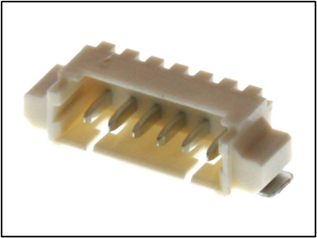

Figure 15: Mating connector part number 532610671

Figure 16: Programming Cable PIN-OUTs J7

### SWD-based Programming

To perform SWD-based programming, the module must be connected as shown in Figure 18.

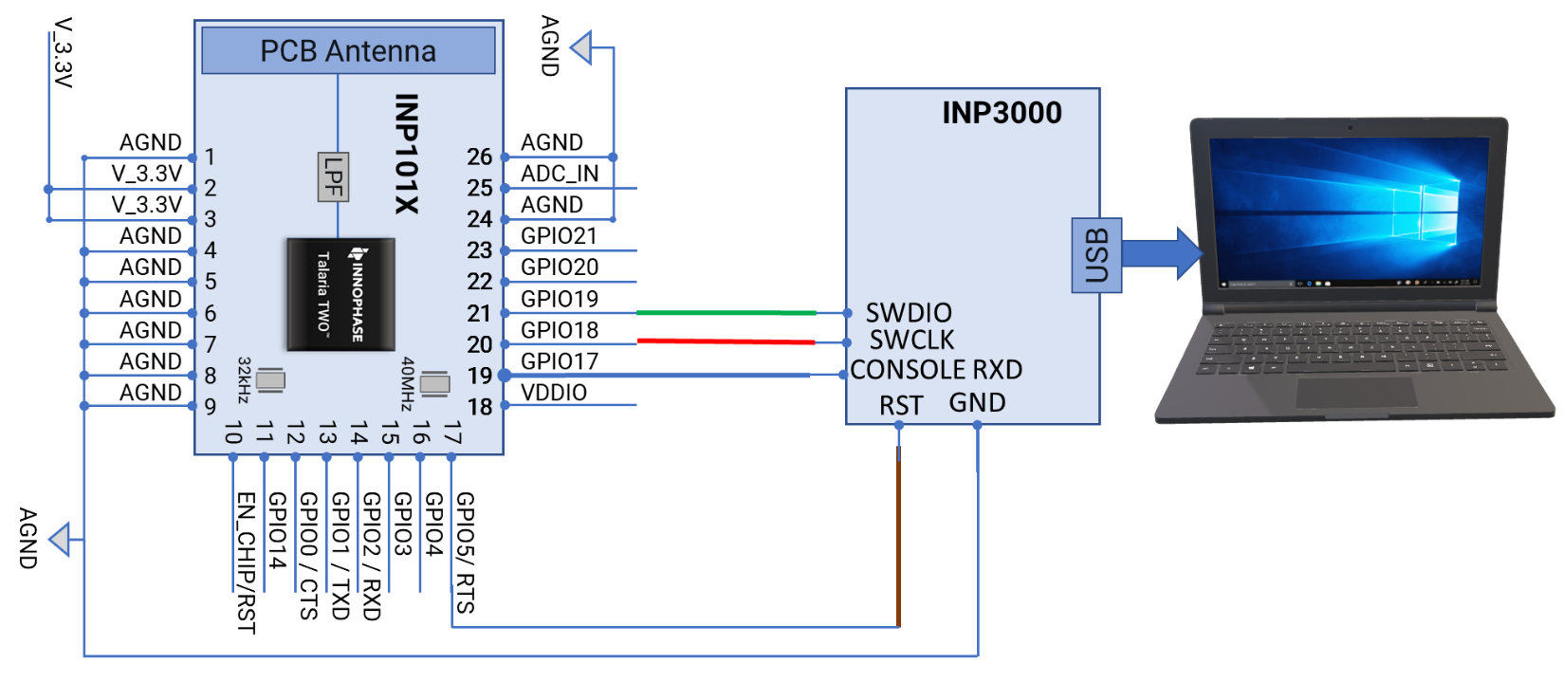

Figure 18: SWD-based programming

In case of a custom application board, it is recommended to use the INP3000 programmer board to program the module. The INP3000 programmer board comes with a 10 pin 1.27mm connector on board with part number 3221-10-0100-00. The mating cable part number for SWD is 1528-2009-ND Digikey.

The connector on the INP3000 board is a 10-pin connector with the following connector details:

|  |  |
| --- | --- |
| **PINS** | **PIN DETAILS** |
| 1 | VCC (If VCC required from INP3000 board) |
| 2 | SWDIO/ GPIO19 |
| 3 | GND |
| 4 | SWCLK/ GPIO18 |
| 5 | GND |
| 6 | NC |
| 7 | GPIO17/CONSOLE |
| 8 | NC |
| 9 | GND |
| 10 | EN_CHIP/RST |

Table 11: SWD programming PIN-OUT

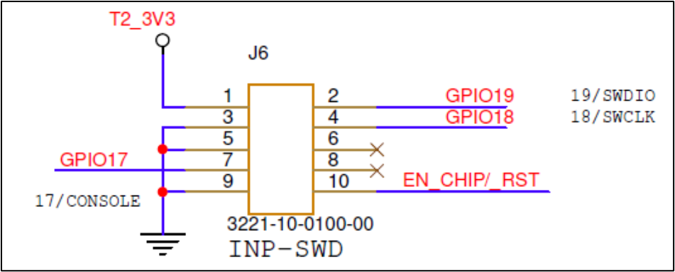

Figure 19: SWD Connector on the application board